|  |  |
| --- | --- |
| **Name** |  |
| **Reg. #** |  |
| **Marks** |  |

# LAB NO 3: Linear time invariant system(LTI) and representation

**Introduction:**

Linear, time-invariant (LTI) systems are the primary signal-processing tool for modeling the action of a physical phenomenon on a signal, such as propagation and measurement. LTI systems also are a very important tool for processing signals. For example, filters are almost always LTI systems. In this lesson you will learn the definition of a system and the important system properties of linearity, time-invariance, and causality.

**Objectives:**

To study the LTI system and its representation using MATLAB software.

**Examples of Creating LTI Models**

Building LTI models with Control System Toolbox is straightforward. The following sections show simple examples. Note that all LTI models, i.e. TF, ZPK and SS are also MATLAB objects.

**Example of Creating Transfer Function Models**

You can create transfer function (TF) models by specifying numerator and denominator coefficients. For example,

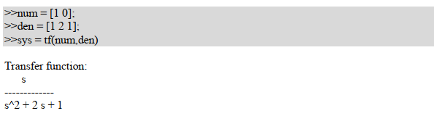

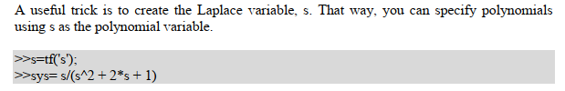

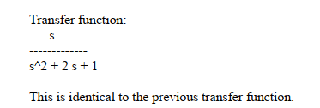

**Example of Creating Zero-Pole-Gain Models**

To create zero-pole-gain (ZPK) models, you must specify each of the three components in vector format. For example,

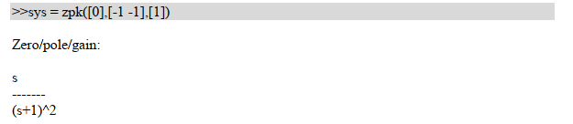

**Plotting poles and zeros of a system:**

**pzmap**

Compute pole-zero map of LTI models



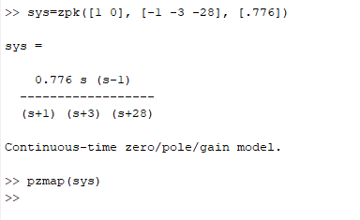

When pzmap command is given output will be like that

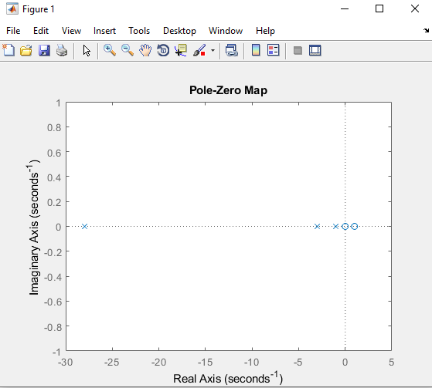



**Simulation of Linear systems to different inputs:**

You can simulate the LTI systems to inputs like impulse, step and other standard inputs and see the plot of the response in the figure window. MATLAB command ‘impulse’ calculates the unit impulse response of the system, ‘step’ calculates the unit step response of the system and ‘lsim’ simulates the (time) response of continuous or discrete linear systems to arbitrary inputs.

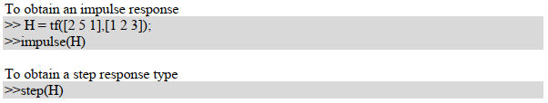

To contain the response of the system you can also specify the time interval to simulate the system to. For example,

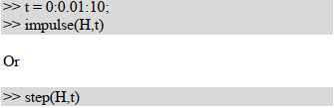

T = 0:dt:Tfinal

